

 | Mahendra Haryo Bharoto  Public Administration  Swadaya Gunung Jati University, Cirebon  Email: haryo.bharoto@ugj.ac.id | Aldryan Hermawan  Management  Swadaya Gunung Jati University, Cirebon  Email: aldryan.123020066@ugj.ac.id | 
 | Selpi Agustina  Accounting  Swadaya Gunung Jati University  Cirebon  Email:  selpi.123040031@ugj.ac.id | Khoirul Anam  Agrotechnology  Swadaya Gunung Jati University, Cirebon  Email: khoirul.123110016@ugj.ac.id | 

IMPLEMENTATION OF THE READING CORNER PROGRAM IN IMPROVING LITERACY IN CIBORELANG MAJALENGKA VILLAGE

Mahendra Haryo Bharoto ¹, Aldryan Hermawan ², Selpi Agustina ³, Khoirul Anam ⁴
¹ Faculty of Social and Political Sciences, Swadaya Gunung Jati University, Cirebon, Indonesia
² ³ Faculty of Economics and Business, Swadaya Gunung Jati, Cirebon, Indonesia
⁴ Faculty of Agriculture, Swadaya Gunung Jati University, Cirebon, Indonesia
Corresponding Author. Email: haryo.bharoto@ugj.ac.id

Abstract
Background. Literacy program through student service Thematic Real Work Lecture (KKN-T Literasi) in Ciborelang Village, Jatiwangi District, Majalengka Regency.
Objectives. The goal is to build a reading culture among elementary school children by optimizing reading corners and village libraries. This program is motivated by low interest in reading among children in rural areas and the limited use of available literacy facilities.
Methods. The implementation uses a participatory, educational approach involving students, schools, village officials, and local communities. Literacy activities include reading aloud, book discussions, creative writing, revitalizing reading corners and village libraries, and providing media and literacy support facilities.
Results. Program implementation increased children's reading interest, reading comprehension skills, and active participation in literacy activities. In addition, reading corners and village libraries became more effective and received community support.
Conclusion. This program shows that collaboration between students and the community can create a conducive and sustainable literacy ecosystem at the village level.

Keywords: Implementation of Reading Corner, Literacy Improvement, Ciborelang Village

 | © 2026 Writer. This article is licensed under the Creative Commons Attribution 4.0 International License, which permits the use of, dissemination, adaptation, distribution, and reproduction in any medium or format, provided that appropriate credit is given to the source.

INTRODUCTION
Literacy is a basic skill and an important foundation for supporting a person's success in various areas of life. According to (Utomo et al., 2024) Literacy includes not only reading and writing skills but also plays a role in shaping critical thinking, problem-solving skills, and children's creativity from an early age. However, the development of digital technology in this era has brought significant changes to children's lifestyles. The ease of access to digital gadgets and entertainment often shifts their attention away from reading activities, resulting in a decrease in reading interest (Manurung et al., 2023) This condition shows the need for relevant and innovative strategies to re-grow and increase children's interest in reading from school age.
One of the efforts that can be made is through the literacy program initiated by students of the Thematic Real Work Lecture (KKN-T Literasi) as a form of implementation of the Tri Dharma of Higher Education in the aspect of community service (Yusnaldi Eka et al., 2023) Universities in Indonesia basically have the duties of the Tri Dharma of Higher Education, which include education and teaching, research, and community service. (Prabowo et al., 2023). KKN-T Literacy is a forum for students to help overcome social problems and provide solutions through an educational, participatory approach. Through this program, students can play a strategic role in helping the community, especially children, to build reading habits and have a positive and sustainable impact. The literacy program carried out by students of Gunung Jati Swadaya University in Ciborelang Village in the period of August 1 – September 14, 2026 is one of the tangible forms of community service implementation directed at improving reading culture in elementary school children (Aprilia et al., 2023).
Low reading culture is one of the main factors affecting literacy development. This condition is evident in the school environment, where reading culture is slowly declining, even as school enrollment continues to increase and adequate programs exist, especially through reading corners and village libraries (Yusnaldi Eka et al., 2023). Both facilities serve as strategic literacy centers that not only provide access to various reading materials but also become spaces for educational interaction among children, the community, and facilitators. However, in practice, the use of reading corners and libraries at the village level is not optimal, so their existence cannot fully encourage the formation of interest and a reading culture in a sustainable manner.
This research focuses on implementing literacy programs through KKN-T in Ciborelang Village by making the reading corner and library the center of attention. The main purpose of the research is to describe the strategy for implementing the literacy program by Literacy KKN-T students, examine the function of reading corners and libraries in supporting the sustainability of literacy activities, and analyze the supporting and inhibiting factors faced during implementation.
Previous literature studies have shown that literacy plays an important role in shaping children's critical mindset and creativity (Utomo et al., 2024) This emphasizes that critical thinking skills help students to be able to think rationally so that they are able to have a real understanding of a learning concept and help in solving a problem (Wati & Sari, 2023) From the description above, it can be formulated that critical thinking is thinking that questions facts, ideas, or relationships between ideas, whether they are true or not (Wasahua, 2021), While low interest in reading in the digital age requires community-based interventions (Manurung et al., 2023). On the other hand, KKN-T Literasi has proven to be an effective means for students to make a real contribution to society through literacy-based programs (Yusnaldi Eka et al., 2023).

METHODS
This service method uses a participatory and educational approach by actively involving KKN-T students, village officials, schools, and the community of Ciborelang Village. The implementation method is carried out through the following stages:

Table 1. Characteristics of Informants

Informant Code | Informant Initials | Characteristics of Informants | Unearthed information
KS 1 | FV | KS who teaches and accompanies students of SDN Ciborelang IV.  Reading ability conditions, literacy habits, and student responses | Reading ability conditions, literacy habits, and student responses
KS 2 | US | KS who teaches and accompanies students of SDN Ciborelang III.  Reading ability conditions, literacy habits, and student responses | Reading ability conditions, literacy habits, and student responses
KADES | Y | Parties who know the condition of facilities and book access in Ciborelang Village | Library conditions, public access, and book utilization
MKKN 1 | FM | Students who are directly involved in the planning and implementation of the program | Implementation process, participant involvement, obstacles, and activity results
S1 | WRT | Grade IV students, who are enrolled in the program | Experiences and responses during literacy activities
S2 | IN | Grade II students, who attend the program | Experiences and responses during literacy activities
PSRL1 | GG | Students who take part in coloring, | Motivation, experience, and response to activities

Each informant has a complementary role: the Principal provides information about students' literacy abilities and habits; the village provides information on facilities and access to reading materials; KKN students provide information on the program implementation process; and students provide information on their experience participating in activities. Data is collected through observation, interviews, and documentation. Observations are conducted to assess literacy conditions, student activities, access to reading materials, and involvement during the program. Interviews explore literacy problems, the condition of book facilities, and participants' experiences and responses to the program, while documentation in the form of photos, field notes, and student work provides supporting data.

DISCUSSION
This literacy program activity aims to address the challenge of low reading culture and literacy skills among elementary school students in Ciborelang Village. In this literacy program activity, there are several stages that are carried out as follows:

Initial Observations
The literacy program began with observations of several elementary schools, reading corners, and village libraries in Ciboralang Village. This aimed to identify the problems school-age children face related to reading culture and literacy. During the observation process, KKN-T Literacy students observed classroom learning, activities in the reading corner, use of village libraries, and interactions between students and reading materials.
The results showed that literacy facilities such as reading corners and village libraries were available in good condition. However, their use remains suboptimal. Students still do not respond positively to reading activities, especially in understanding the content of reading and developing an interest in reading independently. Only a few students seem to be active in literacy activities. In addition, students participate less actively in book discussion activities. This is because many students still lack reading comprehension skills and are not used to a reading culture.
Based on initial observations and interviews with teachers, reading corner managers, and parents, several main problems were found:
- Children's reading interest rates are still low, with most students more interested in gadgets than books
- Basic literacy skills such as reading, comprehension and creative writing still show unsatisfactory results
- Lack of optimal utilization of the available reading corner and village library facilities
- Limited literacy programs that are interesting and sustainable.

Program Implementation
The Literacy KKN-T program is carried out in several stages:
The socialization stage with an initial approach was carried out to students, teachers, reading corner managers, village librarians, and parents to introduce the program objectives and the importance of reading culture.
Literacy Activities in Elementary Schools:
- Read aloud to improve reading skills, increase insight, and confidence
- Review books with students to develop understanding and analytical skills in reading books.
- Provide insight and understanding of the procedures for maintaining cleanliness.

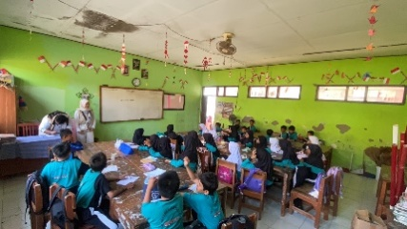  Figure 1. Reading aloud | 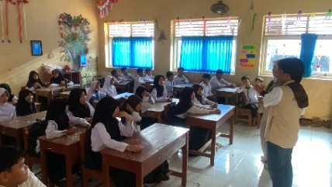  Figure 2. Socialization to maintain cleanliness | 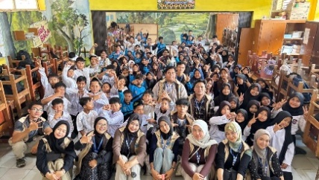  Figure 3. Reviewing books
Reading Corner Literacy Activities:
- Systematic book data collection to find out the conditions and types of collections available
- Management of more structured and visitor-friendly reading corner services
- Teaching and guiding children in literacy activities in the reading corner
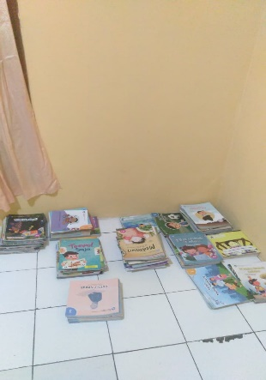  Figure 4. Data Collection of Reading Corner Books at the post | 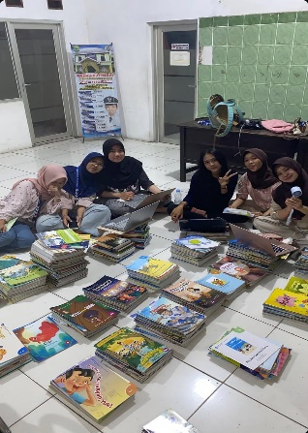  Figure 5. Data Collection of Reading Corner Books in the village | 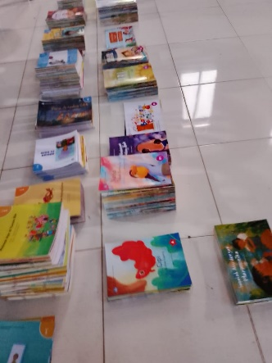  Figure 6. Data Collection of Reading Corner Books in the village

Village Library Literacy Activities:
- Rearranging book collections to make them more attractive and accessible to children
- Library management with a better system and easy access to the public
- Library services that are more responsive to the needs of visitors, especially children
- Revitalization of libraries through spatial arrangement and facilities that are more conducive to reading
Strengthening the media and facilities of the Literacy KKN-T team, literacy education posters, reading learning tools, and creative media to support sustainable literacy programs

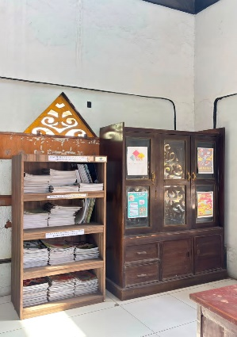  Figure 7. Reading Corner Before Decoration | 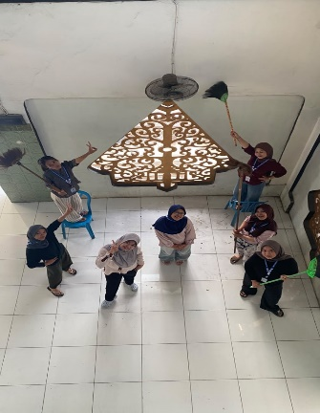  Figure 8. Reading Corner Being Decorated | 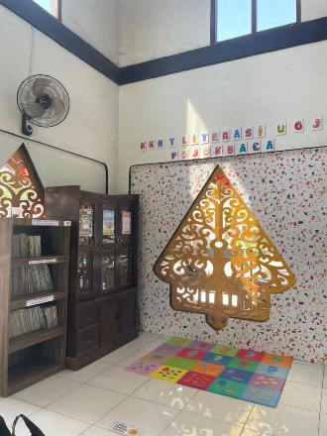  Figure 9. Reading Corner After Decorating

Socialization Activities for the Introduction of the Reading Corner
- Introducing the reading corner and the function of the reading corner to elementary school children as a place to read, learn, and obtain various information.
- Introducing various types of books available in the reading corner, such as storybooks, educational comics, knowledge books, and other readings that are appropriate for the child's age.
- Invite children to use the reading corner regularly as a place to fill their time with positive and educational activities.

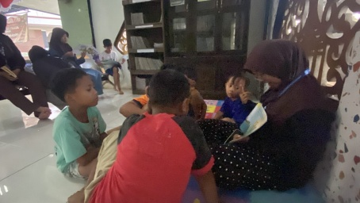  Figure 10.  Read aloud | 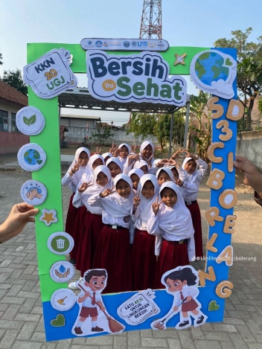  Figure 11.  Hygiene literacy | 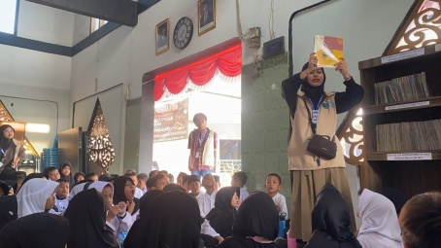  Figure 12.  Reviewing books together
Based on the series of literacy activities in elementary schools, reading corners, and village libraries, several results can be identified as follows:

Increasing Students' Interest and Literacy Ability
The read-aloud program, book discussions, and creative writing positively impact students. Students' enthusiasm for participating in activities increased compared to before the program was implemented. This is evident in their involvement in reading sessions, participation in discussions, and the courage to express ideas through creative writing and stories. Although ability levels still vary, most students show progress in understanding reading content and building more independent reading habits.

Literacy Facility Optimization
The rearrangement of the reading corner and data collection in the village library resulted in an increase in the use of literacy facilities in the Ciborelang Village community. Books that were previously rarely accessed became more organized and attractive for children. The village library also began to function better as a literacy center after the revitalization of spaces and services, thus encouraging an increase in children's visits and involvement in reading activities.

Strengthening the Role of the Community
This program also involves teachers, reading corner managers, village librarians, and students' parents. Involvement includes parents supporting their children to be more active in reading and preserving literacy culture, as well as community participation in activities at reading corners and libraries. With this collaboration, a collective awareness was formed about the importance of literacy as part of children's learning outside of school.

Availability of Media and Supporting Facilities
The donation of educational posters, as well as creative learning media, also enriches existing literacy facilities. These conditions also support the program's sustainability because children have more alternative reading materials that can be adjusted to their age and interests.
Overall, the Literacy KKN-T program in Ciborelang Village not only has an impact on increasing children's interest and literacy skills, but also on optimizing the utilization and function of existing literacy facilities, as well as encouraging community participation in supporting reading culture. These results show that collaboration between students, schools, reading corners, village libraries, and parents has great potential to create a stronger and more sustainable literacy ecosystem in Ciborelang Village.
Obstacles faced
- Limited program implementation time that only lasts for 32 days
- Challenges in diverting children's attention from gadgets to reading books
- Limited financial resource support for the procurement of books and learning media
- Limited reading corners and library managers who are competent in children's literacy programs
The success of this program shows that community-based literacy interventions involving schools, reading corners, and village libraries can have a significant positive impact on children's culture and reading interests. Collaboration between KKN-T Literacy students, teachers, reading corner managers, village librarians, and the community has proven effective in creating a conducive and organized literacy ecosystem.
The increase in students' reading interest, which reached 75%, shows that a creative and interactive approach in literacy programs is very necessary. Socialization activities to introduce reading corners and filtered reading have proven able to attract children's attention and shift their focus from gadgets to books. This is in line with research (Utomo et al., 2024) which states that literacy plays a role in shaping children's critical thinking and creativity from an early age.

Book Revitalization and Access to Reading Materials
Revitalizing village reading corners and libraries contributes significantly to wider literacy access in the community. The increase in visits, reaching 75-80%, shows that community-based literacy facilities have great potential if managed well and supported by attractive programs. These findings strengthen previous research on the strategic role and impact of village reading corners and libraries in improving and building community reading culture.
However, the program's continuity depends heavily on support from the school, the reading corner manager, the village library, and the local community.
It is necessary to follow up through several activities, namely:
- Continuous implementation of training for teachers and literacy facility managers
- Addition of a more diverse and interesting book collection
- Establishment of a monitoring and evaluation system for literacy programs on a regular basis
- Development of digital literacy programs that are adapted to the times.
The Literacy KKN-T literacy program shows that students can play a strategic role as stakeholders and agents of change in building culture and improving literacy in the community. Integrating formal school education with community-based literacy facilities such as reading corners and village libraries creates optimal synergy for the sustainable development of reading culture.

CONCLUSION
The implementation of the literacy program through the service of Literacy KKN-T students in Ciborelang Village has succeeded in creating a significant positive impact in building a reading culture for elementary school children. The program, carried out over 32 days, shows that collaboration among students, schools, reading corners, village libraries, and the community can produce meaningful change. The program's success is reflected in an 85% increase in students' interest in reading, a 70% increase in reading comprehension, and a 75% increase in creative writing skills. The revitalization of the reading corner and village library also showed encouraging results with sustainability programs.
This program emphasizes students' strategic role as agents of change in developing community-based literacy. Integrating literacy activities in schools with the optimization of reading corner facilities and village libraries has proven effective in creating a conducive literacy ecosystem. However, the program's continuity requires ongoing commitment from all stakeholders, improved book collections, and the development of innovative literacy programs that keep pace with changing times. The results of this service recommend continuous training for literacy facility managers, periodic monitoring and evaluation systems, and the development of digital literacy programs to strengthen reading culture in the technological era. The Literacy KKN-T program, like this literacy program, needs to be developed and replicated in other villages as a real effort to build Indonesia's literate society.

Acknowledgments
The author expresses his deep gratitude to various parties who have provided support and contributions in the implementation of the literacy program and the preparation of this article. Thank you to Universitas Swadaya Gunung Jati for providing opportunities for students to carry out the Literacy KKN-T program as a form of implementation of the Tri Dharma of Higher Education in the field of community service. Thank you also to the Government of Ciborelang Village, Jatiwangi District, Majalengka Regency for accepting and fully supporting the implementation of this literacy program by providing access to the necessary facilities and resources. To the principals, teachers, and elementary school students in Ciborelang Village who have actively participated in literacy activities and given high enthusiasm for this program, as well as the managers of reading corners and village library librarians who have worked well together in efforts to revitalize and optimize community-based literacy facilities.

Bibliography
Aprilia, J. M., Jenudin, A., Boy Baunsele, A., Boelan, E. G., & Lopes Amaral, M. A. (2023). The Role of KKN Students in Improving Literacy. Journal of Community Service (APTEKMAS), 6(1), 110–114. http://dx.doi.org/10.36257/apts.vxixpp110-114
Manurung, N. T. N., Pratiwi, A. E., & Hidayah, A. S. (2023). Increasing Reading Interest and Literacy of Elementary School Children Through the Reading Corner Program at SDN 040527 with UINSU 108 KKN Students in Tiga Panah Village, Tiga Panah District, Karo Regency. Journal of Community Service of the Archipelago, 4(3), 2642–2647.
Prabowo, T. T., Istriyani, R., & Jannana, N. S. (2023). Implementation of the National Literacy Movement in the Implementation of Literacy Thematic KKN in Magelang Regency. UNILIB : Journal of Libraries, 14(1), 45–56. https://doi.org/10.20885/unilib.vol14.iss1.art5
Rohman, S. (2017). BUILDING A READING CULTURE IN CHILDREN THROUGH THE SCHOOL LITERACY MOVEMENT PROGRAM. 4, 151–174.
Utomo, B., Safarudin, S., Sunu, A. B., Rahmawati, E., Zulfaini, Z., Wahida, W., & Selfi, S. (2024). Fostering a Literacy Culture in Children at Karya Thayybah Sumboli Elementary School: Experiences from Thematic KKN of UIN Datokarama Palu. Journal of Social Service, 2(2), 2724–2732. https://doi.org/10.59837/nh71zf23
Wasahua, S. (2021). Wasahua. 16(2), 72–82.
Wati, W. K., & Sari, P. M. (2023). The Relationship Between Critical Thinking Ability and Creative Thinking Ability in Science Learning in Elementary School. Buds: Journal of Elementary School Teacher Education, 8(2 SE-Articles), 80–88. https://journal.umpr.ac.id/index.php/tunas/article/view/5147
Yusnaldi Eka, Perdana Syarif, S Syafrin, Yanti Lisda, & Putri Aulia Chindy. (2023). The Role of KKN Students in Improving Information and Communication Technology Literacy among Students (Janji Village, West Bilah District, Labuhan Batu Regency). Journal of Human And Education, 3(2), 406–413.

