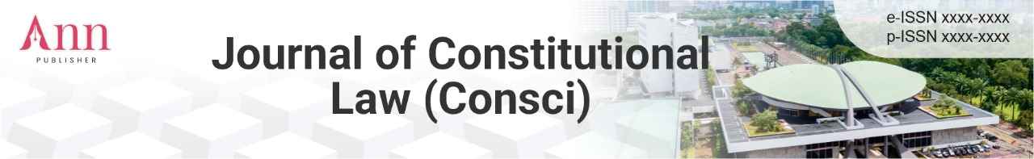
1x spacing
TITLE (CAPITAL LETTERS WRITTEN IN NEW ROMAN FONT TIMES, SIZE 16, CENTER POSITION)
2x spacing

Author 1, Author 2, Author 3 etc. (Each name is written full name, not abbreviated, untitled, justification, Times New Roman font, size 12, middle)
1 Institution, Region, Country, email (Times New Roman font, size 11, middle)
2 Institution, Region, Country, email (Times New Roman font, size 11, middle)
3 Institution, Region, Country, email (Times New Roman font, size 11, middle)
Correspondence Author: Email

Abstract:
Abstracts are written in one paragraph in English with a maximum number of 150-200 words. Use Times New Roman font size 11, space 1. Comprise
Background,
Purpose
Methods,
Results and Discussion
Conclusion
Implications.
Avoid writing citations and abbreviations of literature in the abstract. Don't forget to include the title of the research. (Times New Roman font, size 11, space 1, justification)
1x spacing
Keywords: Consists of 5 words (Times New Roman font, size 11, space 1, justification)
1x spacing

 | © 2025 Author. This article is licensed under the Creative Commons Attribution 4.0 International License, which permits use, sharing, adaptation, distribution, and reproduction in any media or format, as long as you give appropriate credit to the original author and the source.

1x spacing

INTRODUCTION
The introduction contains the background of the research in a concise, concise, and clear manner; the formulation of the problem, the objectives of the research; and the data related to the substance of the research. It doesn't contain many references, except for those that are regulatory, legislative, regulatory, and the like. Writing narratively does not need to be given special subtitles. Included in the writing of operational definitions, if deemed necessary, is also written narratively. (Times New Roman font, size 12, 1.5 spaces, justification)
1x spacing

METHOD
The research method contains the type of research, the sample and the population or subject of the research, the time and place of the research, the instruments, procedures and techniques of the research, and other matters related to the method of research. This section can be divided into subchapters, but it is not necessary to include numbering. (Times New Roman font, size 12, 1.5 spaces, justification)
1x spacing

RESULTS AND DISCUSSION

This section contains data analysis and interpretation of results. Results can be presented with tables or graphs to clarify results verbally because sometimes an illustrated display is more complete and informative than a narrative display. This section should answer a previously formulated research problem or hypothesis. (Times New Roman font, size 12, 1.5 spaces, justification)
1x spacing

Table

For tables, the table description is placed at the top of the table. The caption is written in the middle with a space 1 space away from the table. Like the image caption, the table caption is also given a sequence number. The table source writing is placed below the table. (Times New Roman font, size 11, space 1, justification)

1x spacing
Table 1. Teacher-student ratio in three countries (Indonesia, China, and India)
based on education level in 2025

Country | Sd | Junior High School | Secondary school | Vocational High School
Indonesia | 1:13 | 1:12 | 1:10 | 1:10
Chinese | 1:8 | 1:10 | 1:10 | 1:09
India | 1:12 | 1:11 | 1:11 | 1:10

Source: Research Data
1x spacing

Picture

The image is centered and referenced in line with the text. The image caption is written below the image with numbers. The caption of the image begins with a capital letter. (Times New Roman font, size 11, space 1, justification)
1x spacing
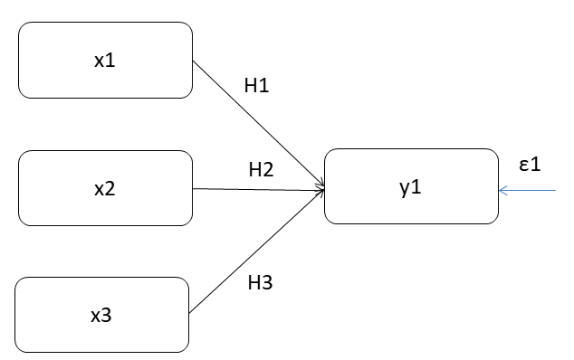
Source: Research images.
Figure 1. Frame of mind
Space1x

CONCLUSION

The conclusion should be related to the title and answer the formulation or purpose of the research. Don't make statements that aren't adequately supported by your findings. Write down improvements made to industrial engineering or science in general. Don't create further discussions, repeat abstracts, or just list the results of your research. Don't use bullet points, use paragraph sentences instead. (Times New Roman font, size 12, 1.5 spaces, justification)
3x spacing

IMPLICATION
Explain the implications of this publication for academia, society, nations and countries, and the international community.

Acknowledgements:
Include a thank you to the sponsor who has supported your publication. (Acknowledgement written in bold sentence case in Times New Roman font, size 11, space 1, justify)

2x spacing
BIBLIOGRAPHY
This section contains only references that are actually referenced. Thus, references included in this section will be found written in the previous section. Writing a bibliography consists of the author's name, year of publication, article title, name of city and publishing institution. Bibliographies are sorted by the first letter of the author's name (A-Z), not necessarily grouped by book, journal, newspaper, or other type of publication. Written with a space of 1. If in 1 reference there is more than one line, then the second line and so on are indented. Bibliography should be articles taken from recent journals or publications. The systematics of writing are as follows: (Font Times New Roman, size 12, space 1, justification)

Writing systematics for this book:
The author's name (on the back). Year of Publication. Book title. City: Publisher
Example:
Datta, FU (2023). Basic Science of Nutrition and Animal Feed. Deepublish.
Systematic journal writing:
Author's name *upside down. Year of publication. The Title of the Article. Journal Name. Volume (Number), p:.
Example:
Nisa, ANK, & Fadin, DI (2023). A Comparative Study of Responsible Tourism through a Pro-Poor Tourism Approach in Kali Gajahwong Tourism Village and Kode Tourism Village. Journal of Tourism Education, 3(1), 35-44.
Nisa, A. N. K., Fadin, D. I. N., & Gustiarti, P. O. Experiencing Museum: Exploration of Digital Free Tourism at the Ullen Sentalu Museum, Yogyakarta. National Journal of Tourism, 13(2), 180-194.
Continue
Nisa, AKK (2022, December). The Impact of Viral Phenomena and Destination Unpreparedness on the Sustainability of Tourist Attractions (Case Study at Amaryllis Flower Garden, Yogyakarta). In the Proceedings of the 2nd International Joint Conference on Hospitality and Tourism, IJCHT 2022, 6-7 October 2022, Singaraja, Bali, Indonesia.
Systematics of Thesis Writing/Thesis/Dissertation:
Author's name *upside down. Year. Title of thesis/dissertation. Thesis/Thesis/Dissertation. City: Institution.
Example:
Alam, IS (2021). The impact of hematological malignancies on women. (Impact of hematological malignancies on women) (Doctoral dissertation, Hasanuddin University).
Widyani, RR (1999). Requirements of amino acids in broiler feed in Indonesia (Doctoral dissertation, Gadjah Mada University).
Writing systematics for articles and the Internet:
Author's name *upside down. Year of publication. The Title of the Article. [Online] Available: site address. [access date, month, year]
Example:
Maxwell, K. (2001). Positive Learning Disposition in Mathematics. [Online] Availability: http://www.education.auckland.ac.nz/uoa/fms/default/education/docs/word/research/foed_paper/issue11/ACE_Paper_3_Issue_11.doc. [28 January 2013]
Note:
- Submitted manuscripts that do not match the format/template will be rejected immediately
- Standard margin (top 2.5, bottom 3.0, right 2.5, left 3.0)
- Black letters/text color
- 1.5 space spacing
- Font Times New Romance
- Font size 12
- Table and Figure Title Font Size 11
- Font size of table and figure content 11
- 10 header and footer font sizes with Times New Romance font
- Spacing between paragraphs (before and after spaces) = 0
- Distance between subchapters or sections 1x entry
- Number of pages 10-15 pages
- Do not use numbering, other than the problem statement number, discussion
and conclusion. Examples: 1. aaaaa; 2. BBBBB; 3. CCCC; and so on
- If it is necessary to use numbering, use different numbering from the formulation, discussion and conclusion. Examples: a) ppppp; b) qqqqqqq; c). rrrrr; and so on
- Bibliography using the style of the American Psychological Association (APA)

